**INFSCI 2710 Database Management, Fall 2018**

**Homework 2: Relational Algebra, SQL**

**100 pts**

**Due Date: 2/14, at the beginning of the class. Hard copy, please type and print your answers.**

**Note**: Use MySQL to answer all questions. **For each question you need to provide the SQL query and** **also the screen shot of the output of that query** from either phpMyAdmin, MySQL Workbench or from the terminal (if from terminal, make sure it is formatted properly).

**Preparations**: Download code from the class page and load data into MySQL. Running follow by the order create_table.sql -> insert_data.sql

Consider the following schema:

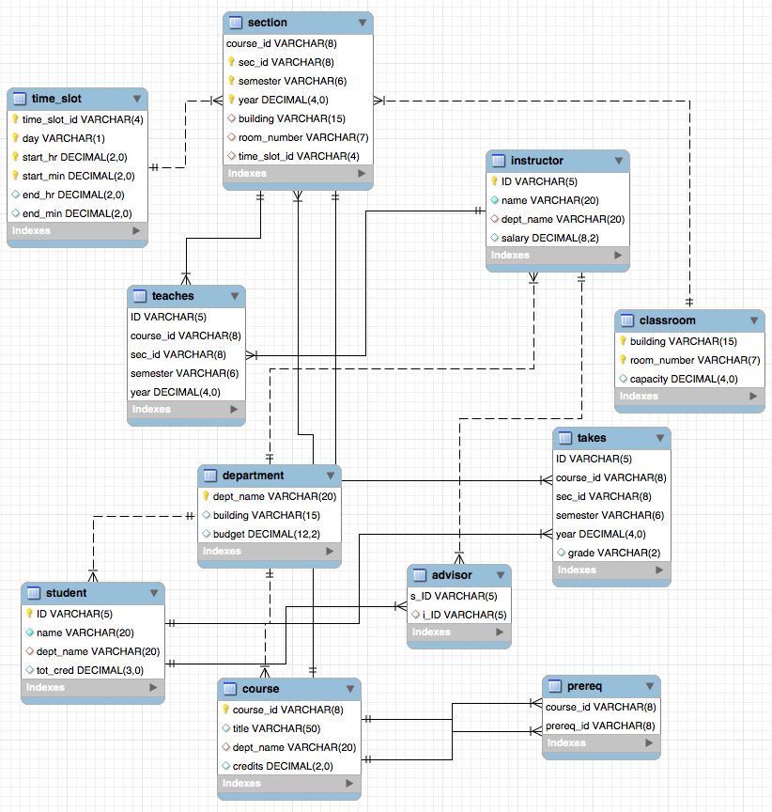

Don’t try to write/adjust your SQL queries by looking the provided data too much. When

checking your homework, we will run your queries on a larger dataset.

Q1[5pt] Count the number of instructors form Physics department.

Answer:

Q2[5pt]: Find the names of courses in Computer science department which have 3 credits.

Answer:

Q3[5pt]: Find all the courses’s name taken by student 98988

Answer:

Q4[10pt]: As above but show the average salary of all the instructor of those courses taken by student 98988.

Answer:

Q5[10pt]: Find the students’ name who take the course in the different department as the student.

Answer:

Q6[10pt]: Find the maximum and minimum enrollment across all sections, considering only

sections that had some enrollment, don't worry about those that had no students taking that section.

Answer:

Q7[5pt]: Find each student ID and the count of courses he/she takes. Display the student ID and course count.

Answer:

Q8[10pt]: Find the student who take more courses than the other students. Display the student ID and course count.

Answer:

Q9[10pt]: Find the student and the largest classroom (biggest room capacity) among all the class he/she has taken. Display the student ID and the room capacity.

Answer:

Q10[15pt]: Find the student (ID) from history department who has taken classes in the largest classroom (biggest the room capacity) compare with other students in history department. Display the student ID and the corresponding room capacity.

Answer:

Q11[15pt]: Find the department that its students take more courses on average than other departments. Display the department, and average count of courses that its student take.

Answer: